Test Case: tc001_SPX_Dev5_Crear_Requisicion_Spot_Tipo_Cobro_CC
Step 1 - Enter username and password and click to button Enter : Credentials Entered
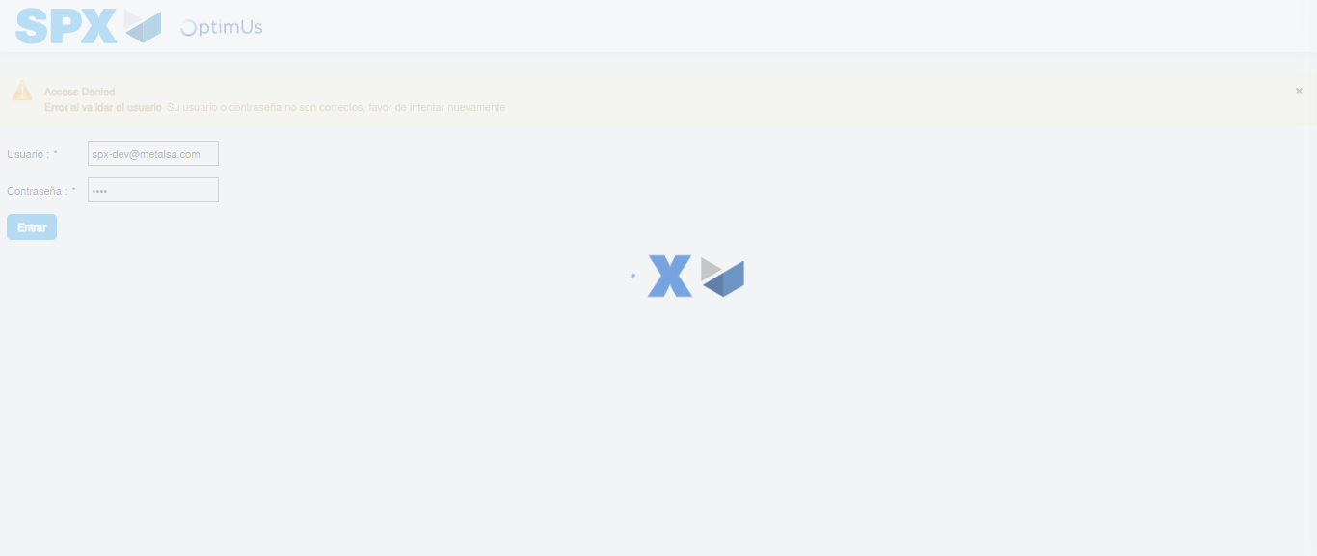Image file-name: QC_Testing-tc001_SPX_Dev5_Crear_Requisicion_Spot_Tipo_Cobro_CC-1782165404968

Step 2 - Select to UEN and Access to Spot Buy Requisitions : UEN Correctly selected and Correct access
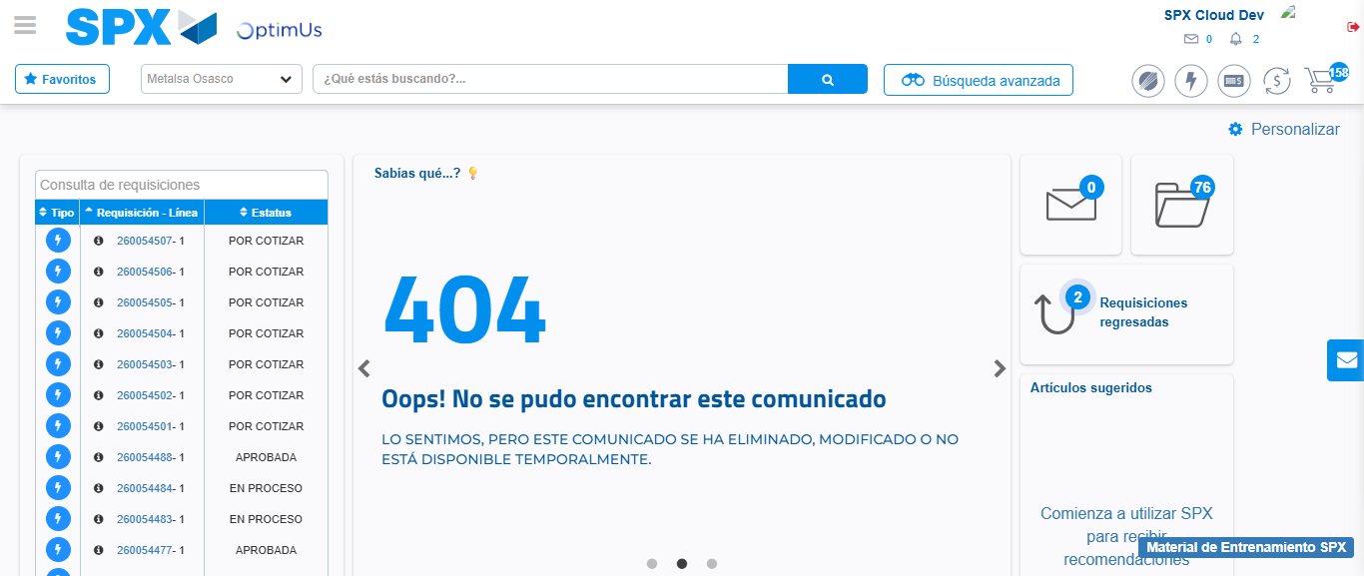Image file-name: QC_Testing-tc001_SPX_Dev5_Crear_Requisicion_Spot_Tipo_Cobro_CC-1782165442547

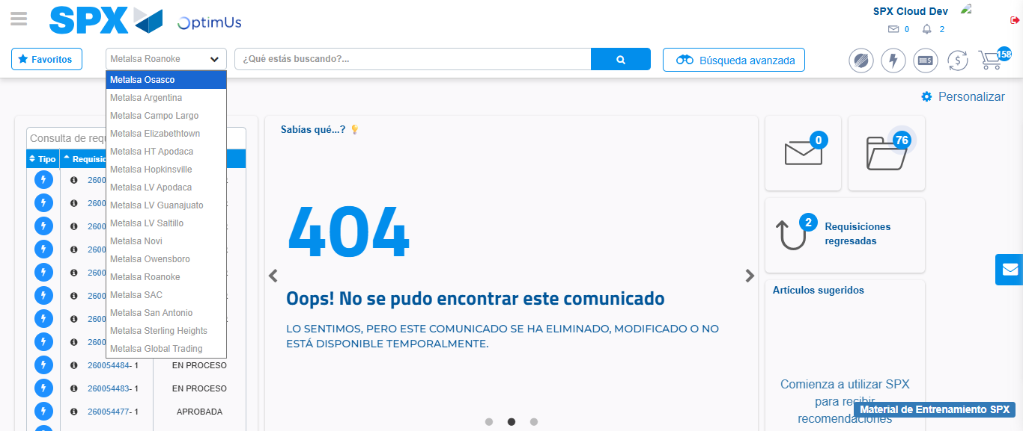Image file-name: QC_Testing-tc001_SPX_Dev5_Crear_Requisicion_Spot_Tipo_Cobro_CC-1782165445071

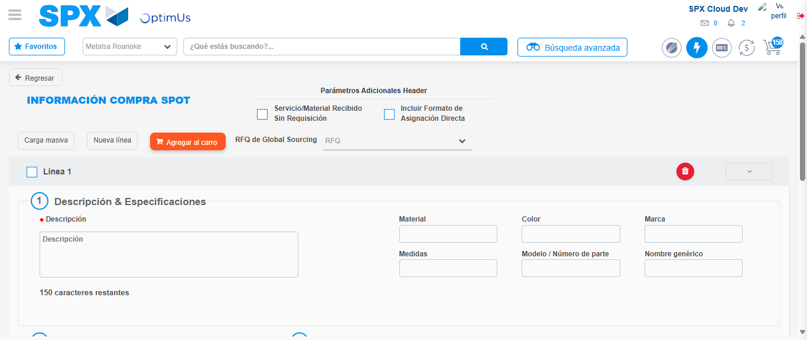Image file-name: QC_Testing-tc001_SPX_Dev5_Crear_Requisicion_Spot_Tipo_Cobro_CC-1782165455373

Step 3 - Data Capture Spot Buy Requisition : Data captured correctly
Image file-name: QC_Testing-tc001_SPX_Dev5_Crear_Requisicion_Spot_Tipo_Cobro_CC-1782165455629

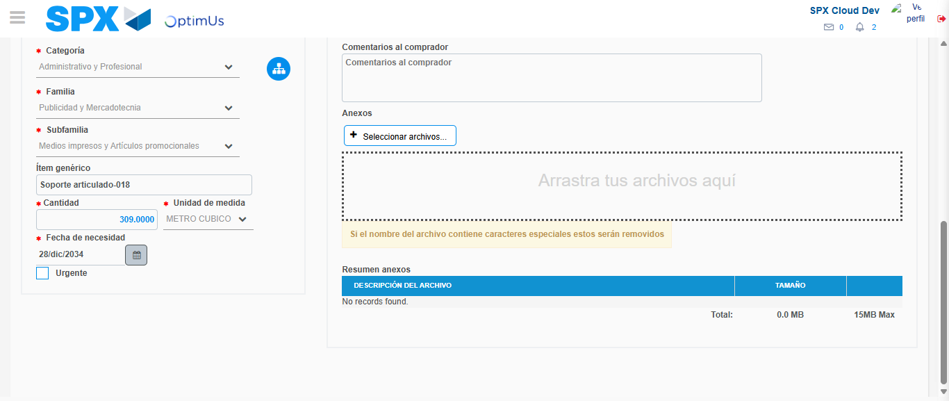Image file-name: QC_Testing-tc001_SPX_Dev5_Crear_Requisicion_Spot_Tipo_Cobro_CC-1782165466659

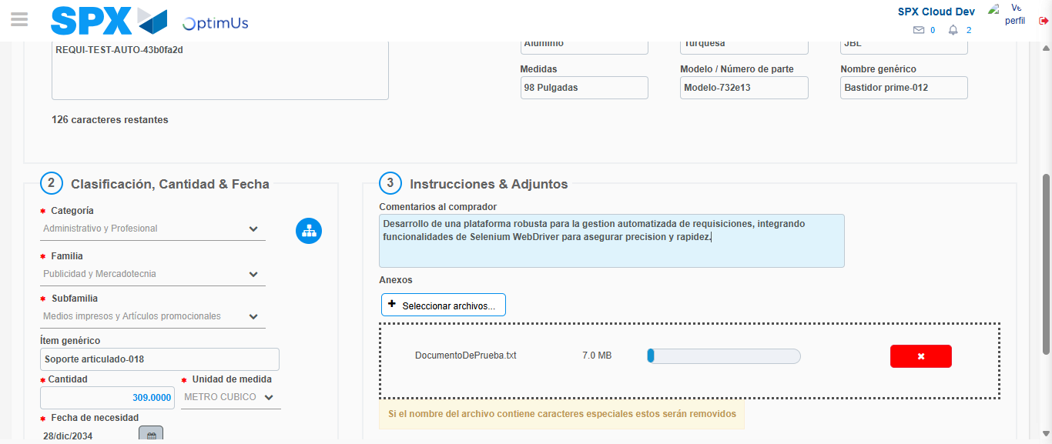Image file-name: QC_Testing-tc001_SPX_Dev5_Crear_Requisicion_Spot_Tipo_Cobro_CC-1782165467405

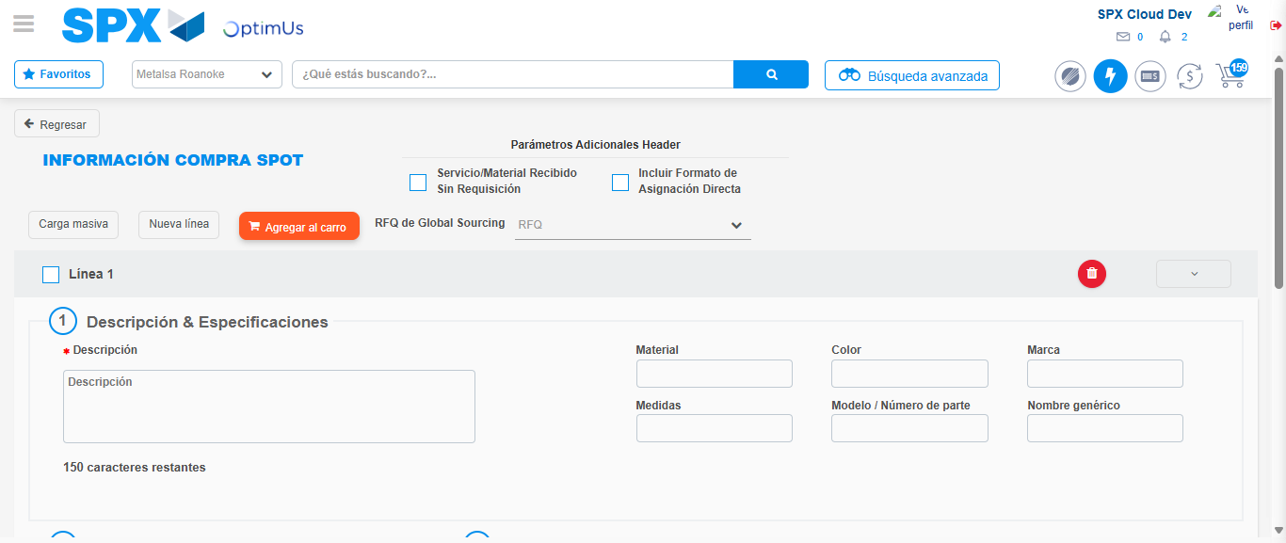Image file-name: QC_Testing-tc001_SPX_Dev5_Crear_Requisicion_Spot_Tipo_Cobro_CC-1782165472396

Step 4 - Select to Requisition : Requisition Correctly selected
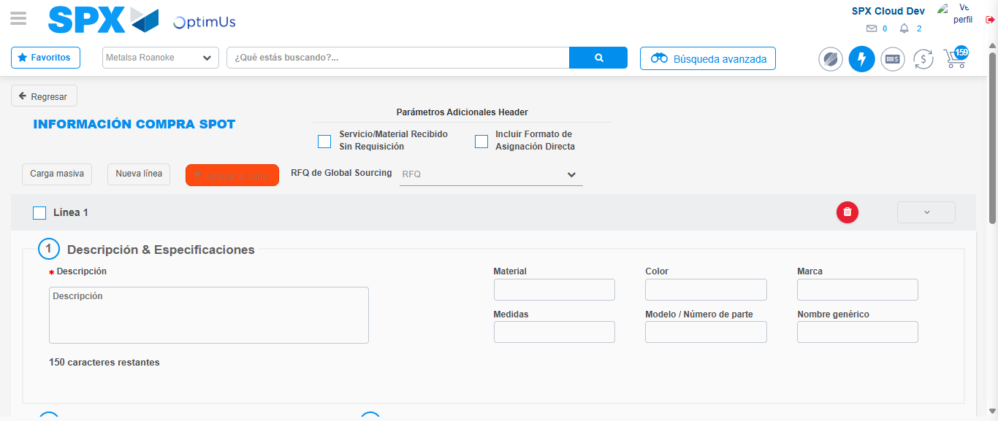Image file-name: QC_Testing-tc001_SPX_Dev5_Crear_Requisicion_Spot_Tipo_Cobro_CC-1782165472605

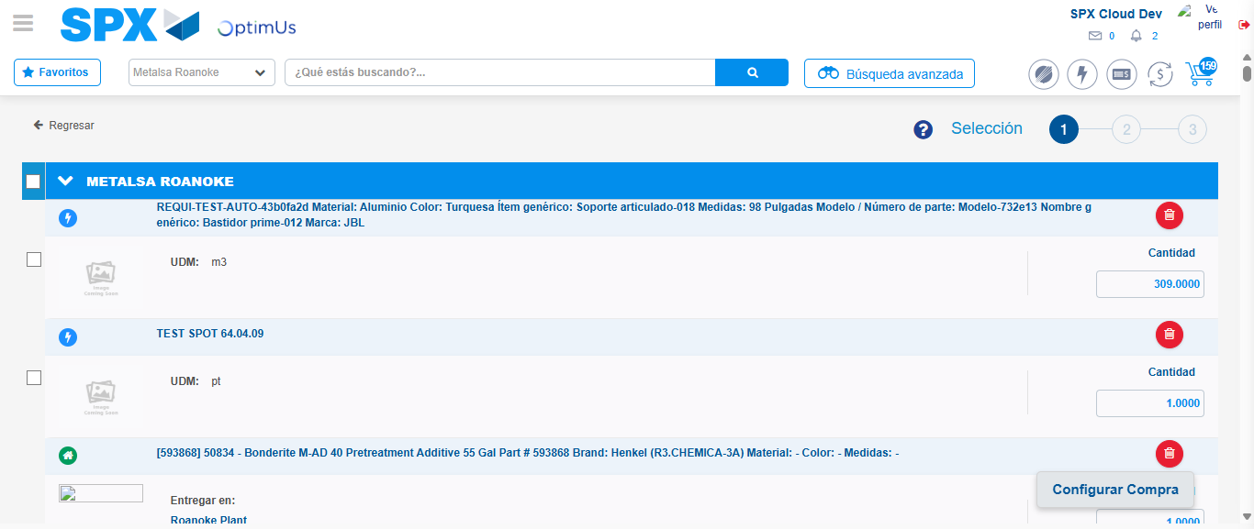Image file-name: QC_Testing-tc001_SPX_Dev5_Crear_Requisicion_Spot_Tipo_Cobro_CC-1782165488356

Image file-name: QC_Testing-tc001_SPX_Dev5_Crear_Requisicion_Spot_Tipo_Cobro_CC-1782165488575

Image file-name: QC_Testing-tc001_SPX_Dev5_Crear_Requisicion_Spot_Tipo_Cobro_CC-1782165488761

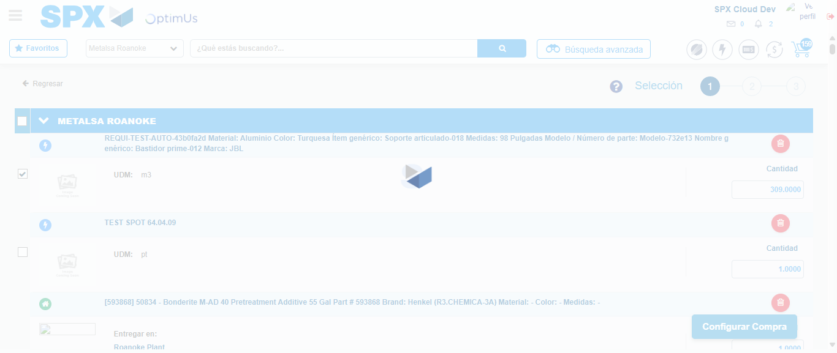Image file-name: QC_Testing-tc001_SPX_Dev5_Crear_Requisicion_Spot_Tipo_Cobro_CC-1782165490683

Step 5 - Select Type Account For Requisition : Type Account Correctly selected
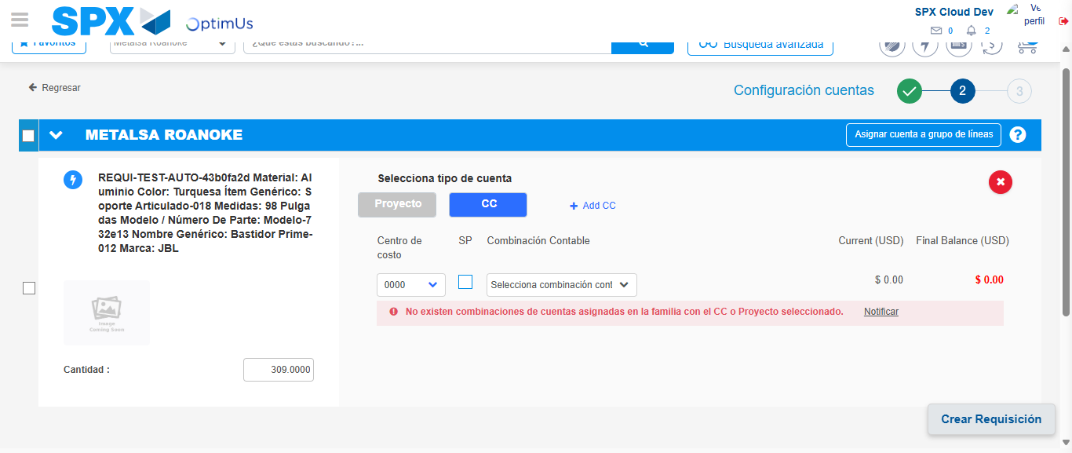Image file-name: QC_Testing-tc001_SPX_Dev5_Crear_Requisicion_Spot_Tipo_Cobro_CC-1782165504567

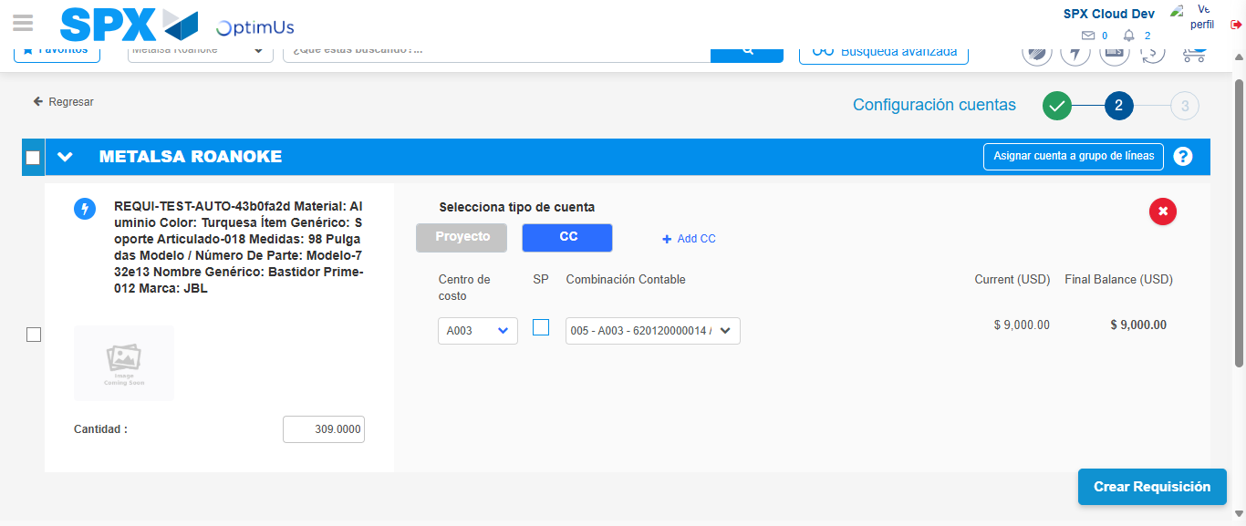Image file-name: QC_Testing-tc001_SPX_Dev5_Crear_Requisicion_Spot_Tipo_Cobro_CC-1782165509740

Image file-name: QC_Testing-tc001_SPX_Dev5_Crear_Requisicion_Spot_Tipo_Cobro_CC-1782165509893

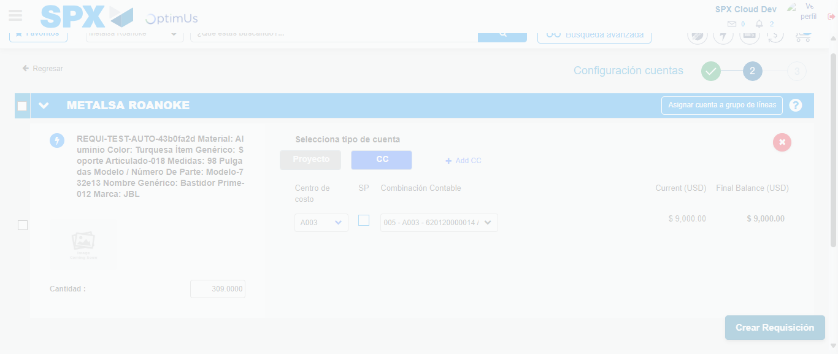Image file-name: QC_Testing-tc001_SPX_Dev5_Crear_Requisicion_Spot_Tipo_Cobro_CC-1782165510292

Step 6 - Accept to Requisition : Requisition Accepted
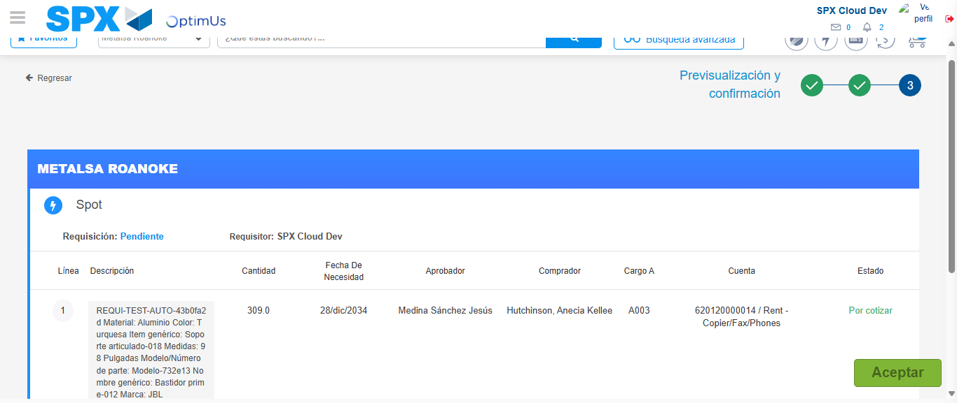Image file-name: QC_Testing-tc001_SPX_Dev5_Crear_Requisicion_Spot_Tipo_Cobro_CC-1782165511567

Image file-name: QC_Testing-tc001_SPX_Dev5_Crear_Requisicion_Spot_Tipo_Cobro_CC-1782165511763

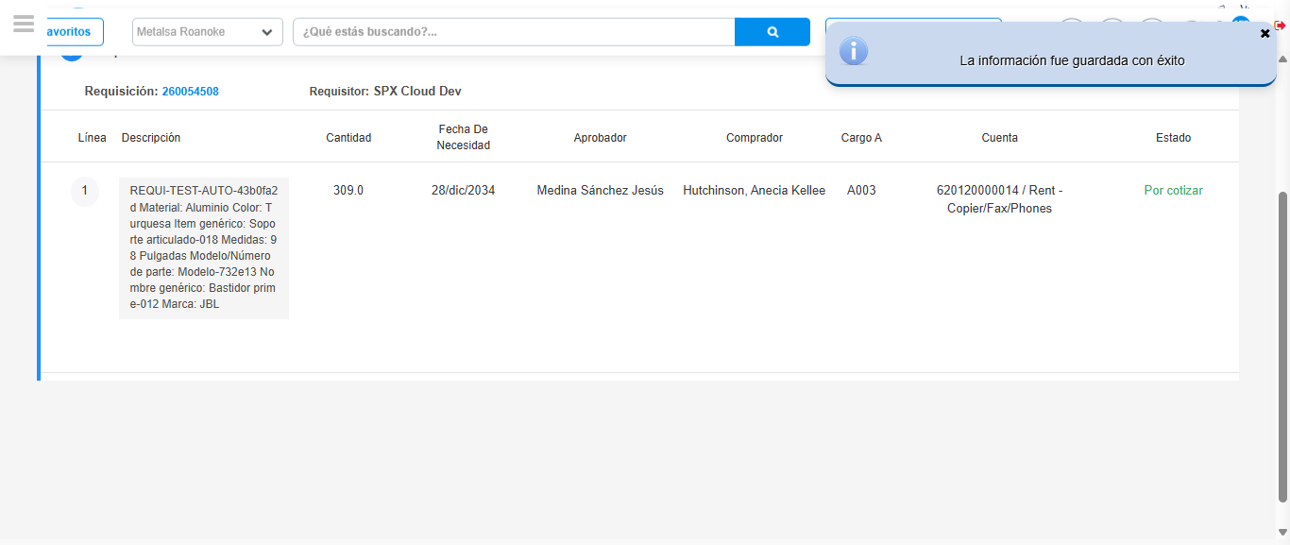Image file-name: QC_Testing-tc001_SPX_Dev5_Crear_Requisicion_Spot_Tipo_Cobro_CC-1782165515220

Step 7 - Return to Main Page SPX : Return to Main Page SPX
Image file-name: QC_Testing-tc001_SPX_Dev5_Crear_Requisicion_Spot_Tipo_Cobro_CC-1782165442547

Image file-name: QC_Testing-tc001_SPX_Dev5_Crear_Requisicion_Spot_Tipo_Cobro_CC-1782165445071

Image file-name: QC_Testing-tc001_SPX_Dev5_Crear_Requisicion_Spot_Tipo_Cobro_CC-1782165455373

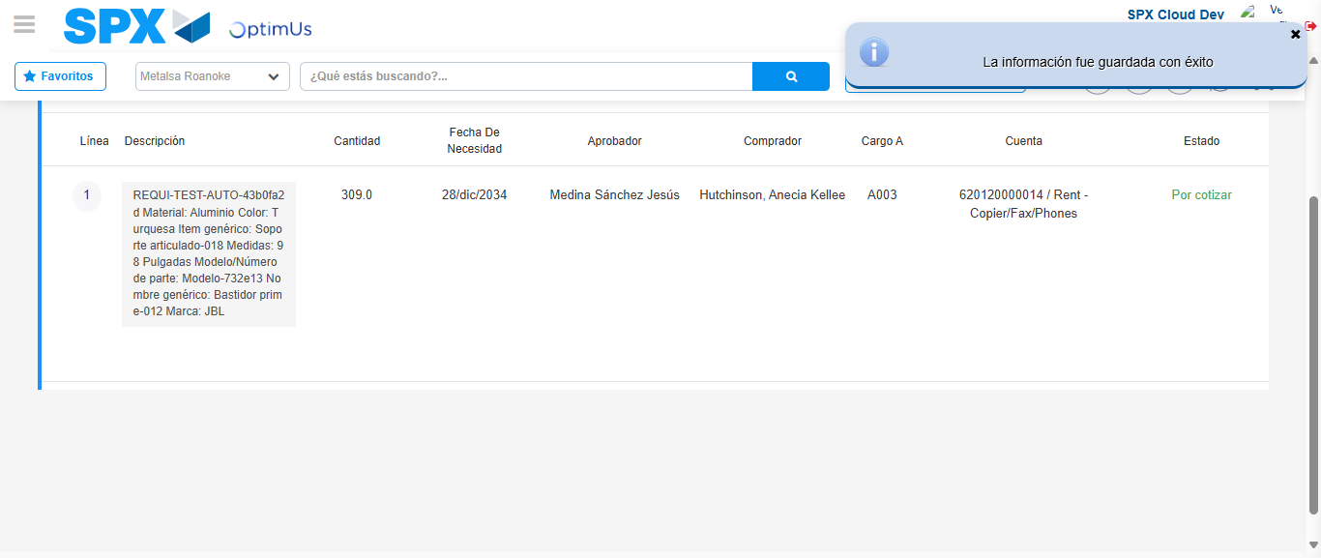Image file-name: QC_Testing-tc001_SPX_Dev5_Crear_Requisicion_Spot_Tipo_Cobro_CC-1782165517452

Image file-name: QC_Testing-tc001_SPX_Dev5_Crear_Requisicion_Spot_Tipo_Cobro_CC-1782165517630

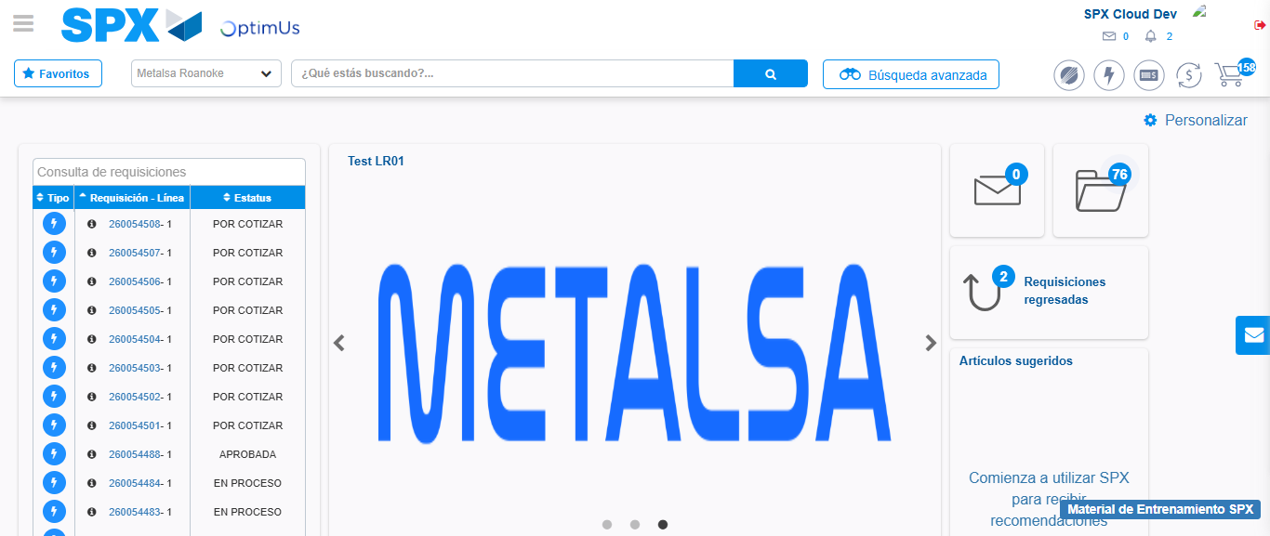Image file-name: QC_Testing-tc001_SPX_Dev5_Crear_Requisicion_Spot_Tipo_Cobro_CC-1782165538782

Step 8 - Log Out : Log Out SPX
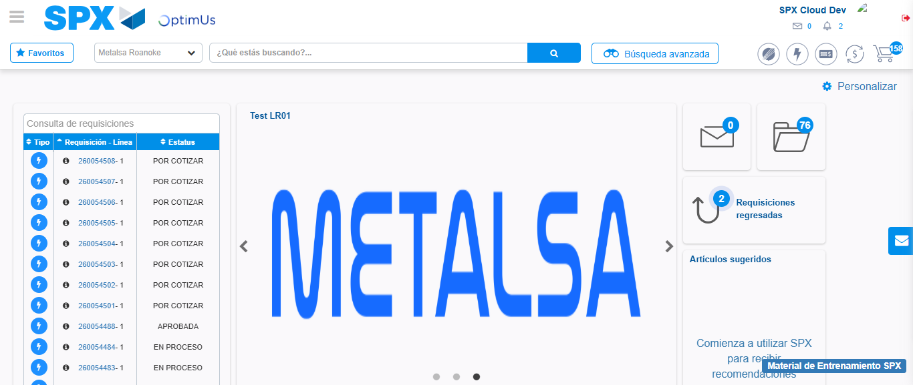Image file-name: QC_Testing-tc001_SPX_Dev5_Crear_Requisicion_Spot_Tipo_Cobro_CC-1782165539068

